:: Segment-01

Preliminaries

Introduction to Accounting

- Accounting is famously known as the "language of business".

- Let us take an example.
In Bangladesh, there is a basic rule to be followed by everyone that one should walk or drive on his/her left-hand side of the road. It helps in the smooth flow of traffic. Similarly, there are certain rules that an accountant should follow while recording business transactions and preparing accounts. These may be termed as accounting concept.
Thus, this can be said that: Accounting concept refers to the basic assumptions and rules and principles which work as the basis of recording of business transactions and preparing accounts.

- For accounting purposes,
The business enterprise and its owners are two separate independent entities. Thus, the business and personal transactions of its owner are separate. For example, when the owner invests money in the business, it is recorded as liability of the business to the owner. Similarly, when the owner takes away from the business cash/goods for his/her personal use, it is not treated as business expense. Thus, the accounting records are made in the books of accounts from the point of view of the business unit and not the person owning the business. This concept is the very basis of accounting.
Let us take an example: Suppose Mr. Abdul Wakill started business investing Tk 1,00,000. He purchased goods for Tk 40,000, Furniture for Tk 20,000 and plant and machinery of Tk 30, 000. Tk 10,000 remains in hand. These are the assets of the business and not of the owner. According to the business entity concept Tk 1,00,000 will be treated by business as capital i.e. a liability of business towards the owner of the business. Now suppose, he takes away Tk 5000 cash or goods worth Tk 5000 for his domestic purposes. This withdrawal of cash/goods by the owner from the business is his private expense and not an expense of the business. It is termed as Drawings. Thus, the business entity concept states that business and the owner are two separate/distinct persons. Accordingly, any expenses incurred by owner for himself or his family from business will be considered as expenses and it will be shown as drawings.

The need for accounting:

In all activities and organizations (business or non-business) which require money and other economic resources, accounting is required to account for these resources.
In other words, wherever money is involved, accounting is required to account for it.
Accounting helps answering questions like:
- Am I making or losing money from business?
- How much am I worth?
- Should I put money in my business or sell it and go into another business?
- How much is owed to me, and how much do I owe?
- How can I change the way I operate to make more profit?

Objectives of Accounting:
Objectives of accounting may differ from business to business depending upon their specific requirements. However, the following are the general objectives of accounting:
- Keeping systematic record
- Ascertain the results of the operation
- Ascertain the financial position of the business
- Portray the liquidity position
- To protect business properties
- To facilitate rational decision-making
- To satisfy the requirements of law

- Accounting is the systematic recordation of the financial transactions of a business. Such recordation can be split into three activities:
- Setting up a system of record keeping
- Tracking transactions within that system of record keeping
- Aggregating the resulting information into a set of financial reports

These three aspects of accounting are broken down into more detail as follows:
Record keeping system : The system of record keeping for accounting requires the use of a standard set of accounting policies and procedures, as well as standardized forms. The procedures should incorporate controls designed to ensure that assets are used as intended. The record keeping system is commonly built around a commercially available, off-the-shelf accounting software package. The overall system will likely need to be designed around the software, to ensure that all features of the software are fully employed.
Transaction tracking: A separate procedure is needed to collect information about each type of business transaction. For example, separate systems are needed to process customer orders, bill customers, and collect cash from customers. Transaction tracking occupies the bulk of the time of the accountant.
Financial reporting : Several accounting frameworks, most notably GAAP and IFRS, mandate a specific manner in which business transactions must be treated in the accounting records and aggregated into the financial statements. The result is an income statement, balance sheet, statement of cash flows, and supporting disclosures that describe the results of a reporting period and the financial position of the reporting entity at the end of that period.
In short, the meaning of accounting covers a broad range of activities, but can be aggregated into a data collection system, the ongoing collection of data into that system, and the reporting of information from that system.

- Technical definitions of accounting have been published by different accounting bodies.
The American Institute of Certified Public Accountants (AICPA) defines accounting as:

“The art of recording, classifying and summarizing in a significant manner and
in terms of money, transactions and events which are, in part at least of financial character,
and interpreting the results thereof”.

Studying the statement above will give us a better understanding of accounting.
1. Accounting is considered an art-
Accounting is considered an art because it requires the use of skills and creative judgment. One has to be trained in this discipline to be able to perform accounting functions well.
Accounting is also considered a science because it is a body of knowledge. However, accounting is not an exact science since the rules and principles are constantly changing (improved).
2. Accounting involves interconnected "phases"-
Recording pertains to writing down or keeping records of business transactions. Classifying involves grouping similar items that have been recorded. Once they are classified, information is summarized into reports which we call financial statements.
3. Concerned with transactions and events having financial character-
For example, hiring an additional employee is qualitative information with no financial character. Hence, it is not recorded. However, the payment of salaries, acquisition of an office building, sale of goods, etc. are recorded because they involve financial value.
4. Business transactions are expressed in terms of money-
They are assigned amounts when processed in an accounting system. Using one of the examples above, it is not enough to record that the company paid salaries for April. It must include monetary figures – say for example, $20,000 salaries expense.
5. Interpreting the results-
Interpreting results is part of the phases of accounting. Information is useless if they cannot be interpreted and understood. The amounts, figures, and other data in the financial reports have meanings that are useful to the users.

“Accounting is the process of identifying, measuring & communication economic information to permit informed judgments & decisions by the users of the information.” - A.A.A.

“Accountancy may be defined as the collection, complicating & systematic recording business transactions of money, preparation of financial reports, the analysis & interpretation of these reports & the use of these reports for the information & guidance of management.”- A. W. Johnson

Accounting is the process of communicating financial information about a business entity to users such as shareholders and managers. A key product of an accounting information system, financial statements allow people to make informed business decisions. Financial statements are the documents that report on an individual’s or an organization’s in monetary amounts.

Finally, Accounting is the classification, analysis & interpretation of the financial records of enterprises and is a means through which information about a business entity is communicated.

History and Development of Accounting
The name that looms largest in early accounting history is Luca Pacioli, who in 1494 first described the system of double-entry bookkeeping used by Venetian merchants in his “Summa de Arithmetica, Geometria, Proportioni et Proportionalita.” Of course, businesses and governments had been recording business information long before the Venetians. But it was Pacioli who was the first to describe the system of debits and credits in journals and ledgers that is still the basis of today's accounting systems.
The industrial revolution spurred the need for more advanced cost accounting systems, and the development of corporations created large groups who were not part of a firm’s management but had a vested interest in the company’s results—namely, shareowners and bondholders who provided external financing. The rising public status of accountants helped to transform accounting into a profession, first in the United Kingdom and then in the United States. In 1887, thirty-one accountants joined together to create the American Association of Public Accountants. The first standardized test for accountants was given a decade later, and the first CPAs were licensed in 1896.
Branches of Accounting
In order to satisfy needs of different people interested in the accounting information, different branches of accounting have developed. Accounting is generally classified into three different disciplines as shown in the following figure:

- Financial Accounting
- Cost Accounting
- Management Accounting

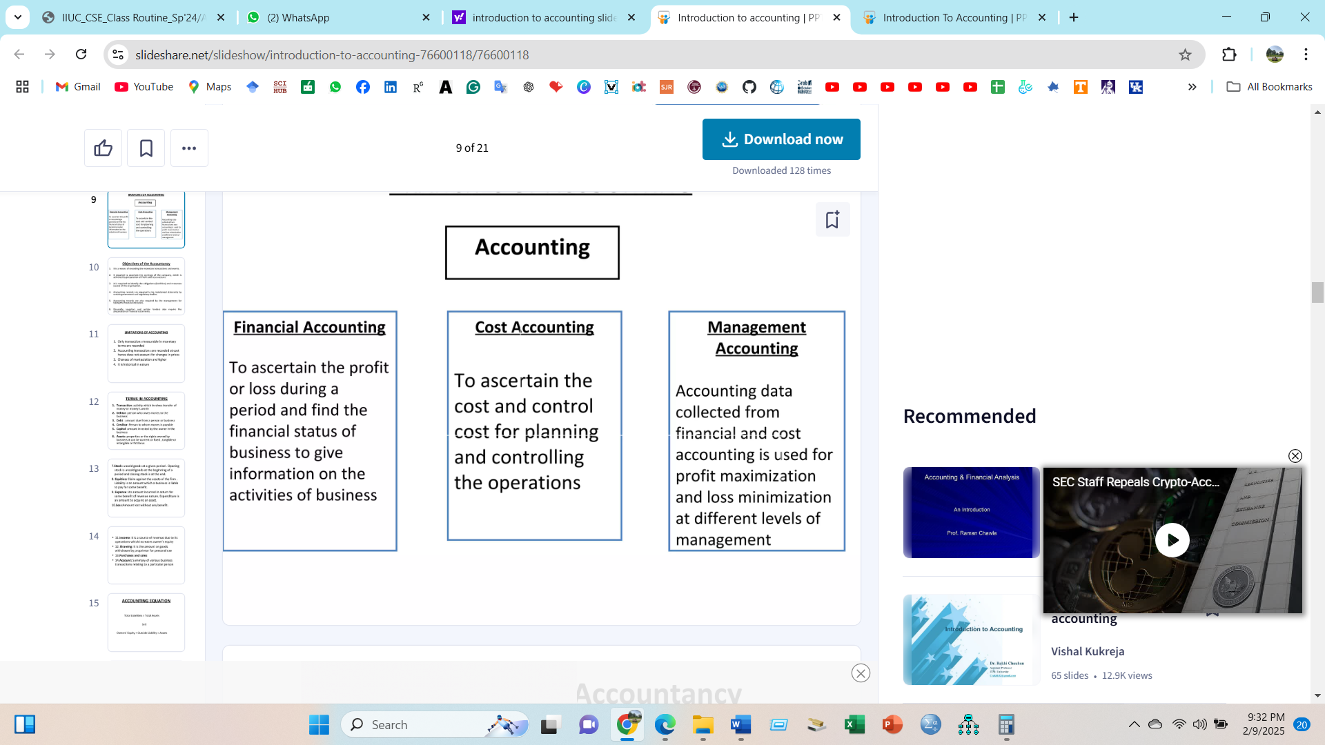
- Financial Accounting:
Financial Accounting is based on a systematic method of recording transactions of any business according to the accounting principles. It is the original form of the accounting process. The main purpose of financial accounting is to calculate the profit or loss of a business during a period and to provide an accurate picture of the financial position of the business as on a particular date.

- Cost Accounting:
Cost accounting deals with evaluating the cost of a product or service offered. It calculates the cost by considering all factors that contribute to the production of the output, both manufacturing and administrative factors. The objective of cost accounting is to help the management in fixing the prices and controlling the cost of production.

- Management Accounting:
This branch of accounting provides information to management for better administration of the business. It helps in making important decisions and controlling of various activities of the business. The management is able to take decisions efficiently with the help of various Management Information Systems such as Budgets, Projected Cash Flow and Fund Flow Statements, Variance Analysis reports, Cost-Volume-Profit Analysis reports, Break-Even-Point calculation, etc.

On the basis of specialized services, Accounting use under two head :

- Public Accounting

- Auditing: is the independent examination that ensures the reliability of the accounting reports that management prepares and submits to investors, creditors and outside of the business.
- Tax Accounting: complying with tax laws, and minimizing taxes to be paid, preparing tax returns
- Management Consulting: describes the wide scope of advice, providing insights and suggestions for improvement in the business management structures and accounting system.

- Private Accounting

- General Accounting: preparation of financial statements
- Cost Accounting: analyzing business costs too help managers controlling expenses
- Budgeting: sets sales and profit goals and developing detailed plans (budgets)
- Information systems design: identifies information need for both internal and external users
- Internal Auditing: performed by business’s own accountatnt

Accounting Principles
Accounting principles follow certain guidelines. The rules that govern how accountants measure, process, & communicate financial information fall under the heading GAAP, which stands for Generally Accepted Accounting Principles.

Generally Accepted Accounting Principles (GAAP) include not only principles but also concepts & methods that identify the proper way to produce accounting information. GAAP comprises all conventions, rules, and procedures that constitute accepted accounting practice at any time. Generally Accepted Accounting Principles are like the law–rules for conducting behavior in a way acceptable to the majority of people. These rules i.e. accounting principles are stated below:

- Principle of regularity: Regularity can be defined as conformity to enforced rules and laws.
- Principle of consistency: This principle states that when a business has once fixed a method for the accounting treatment of an item, it will enter all similar items that follow in exactly the same way.
- Principle of sincerity: According to this principle, the accounting unit should reflect in good faith the reality of the company's financial status.
- Principle of the permanence of methods: This principle aims at allowing the coherence and comparison of the financial information published by the company.
- Principle of non-compensation: One should show the full details of the financial information and not seek to compensate a debt with an asset, revenue with an expense, etc.
- Principle of prudence: This principle aims at showing the reality "as is": one should not try to make things look prettier than they are. Typically, revenue should be recorded only when it is certain and a provision should be entered for an expense which is probable.
- Principle of continuity: When stating financial information, one should assume that the business will not be interrupted. This principle mitigates the principle of prudence: assets do not have to be accounted at their disposable value, but it is accepted that they are at their historical value.
- Principle of periodicity: Each accounting entry should be allocated to a given period, and split accordingly if it covers several periods. If a client pre-pays a subscription (or lease, etc.), the given revenue should be split to the entire time-span and not counted for entirely on the date of the transaction.
- Principle of Full Disclosure/Materiality: All information and values pertaining to the financial position of a business must be disclosed in the records.
- Principle of Utmost Good Faith: All the information regarding to the firm should be disclosed to the insurer before the insurance policy is taken.

Accounting Ethics
“Accountants & the accountancy profession exist as a means of public service; the distinction which separates a profession from a mere means of livelihood is that the profession is accountable to standards of the public interest, and beyond the compensation paid by clients.”
– Robert H. Montogomery, Describing Ethics in Accounting

Luca Pacioli, the ‘Father of Accounting’, wrote on accounting ethics in his first book Suma de Arithmetica, Geometria, Proportioni et Proportionalita (Latin: "Review of Arithmetic, Geometry, Ratio and Proportion"), published in 1494. Ethical standards haave since then been developed through govt. groups, professional organizations, and independent companies. These three groups have led accountants to follow several codes of ethics to perform their duties in a professional work environment. Ethical consideration pervades all areas of accounting & business. Consider a situation that challenged the ethical conduct of the accountant. By what criteria do accountants address questions that challenge their ethical conduct? The AICPA, other professionals accounting organizations and most large companies have codes of ethics that bind their members & employees to high levels of ethical conduct.

Use of Accounting

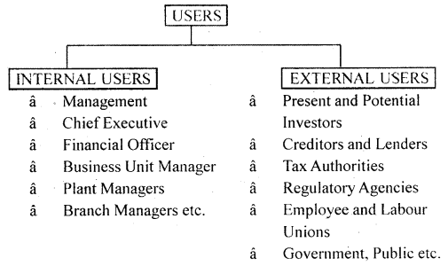
- Individuals: using accounting information to decide which financial decision is more rational among the alternatives i.e., evaluating job prospects, making investments
- Business: for setting the goals of the business, to know about the position of the firm, further expansion or contraction of business or product line,
- Investors & Visitors: investors who want to invest their money in a firm, wish to know about safety of their investment
- Government Regulatory Agencies: for regulation and legislation purpose, listing rules
- Taxing Authorities: taxation purpose
- Non-Profit Organization: dealing with budgets, payroll, rent payment etc.
- Other Users: employees, labor unions, consumer, general public

Types of Business Organization

- Sole Proprietorship: A business owned by a single person who has unlimited liability. The sole proprietorship is the simplest business form under which one can operate a business. The sole proprietorship is not a legal entity. Income and losses are taxed on the individual's personal income tax return. The sole proprietorship is a popular business form due to its simplicity, ease of setup, and nominal cost.

- Partnership : A business organization which has two or more owners, all of whom have unlimited liability, Where two or more individuals pool money, skills, and other resources, and share profit and loss in accordance with terms of the partnership agreement.

- Company: A business organization which is incorporated under the companies act and has limited liability. A group of individuals, such as an association, corporation, partnership, or union, associated for the purpose of carrying out, maintaining, or performing a commercial or industrial enterprise.

Accounting Equation

Asset = Liability + Owners Equity

Asset : Assets are the economic resources of a business that are expected to be of benefit
in the future. Elements of Asset are :
- Cash
- Land
- Building
- Equipment
- Machine
- Furniture
- Office Supplies
- Accounts Receivable
- Notes Receivable
- Prepaid Expense

Liability: Liabilities are outsider claims, which are economic obligation- debts,
payable to outsiders. Elements of Liability are :
- Accounts Payable
- Notes Payable

Owners Equity: Owners Equities are insider claims, the claims held by the owners of business.
Elements of Owners Equity are :
- Capital
- Revenue
- Expenses
- Withdraw

